SQL QUERIES
PIZZA DASHBOARD (MS SQL SERVER)

KPI’s
1.Total Revenue
SELECT SUM(total_price) AS Total_Revenue from [pizza_sales (1)];
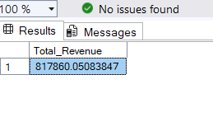
2.Average Order Value
SELECT SUM(total_price) /COUNT(DISTINCT order_id) AS Average_order_Value FROM [pizza_sales (1)];
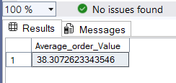

3. Total Quantity of Pizza Sold
SELECT SUM(quantity) AS Total_Pizza_Sold FROM [pizza_sales (1)]; SELECT SUM(quantity) AS Total_Pizza_Sold FROM [pizza_sales (1)];
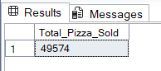
4. Total Orders
SELECT COUNT(DISTINCT order_id) FROM [pizza_sales (1)];
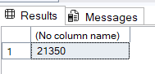
5. Average Pizzas per order
SELECT CAST(CAST(SUM(quantity) AS DECIMAL (10,2))/CAST(COUNT(DISTINCT order_id) AS DECIMAL(10,2)) AS DECIMAL(10,2))
AS Avg_Pizzas_Per_Order
FROM [pizza_sales (1)];
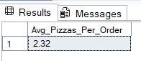
6. Daily Trend for Total orders
SELECT DATENAME(DW,order_date) as order_day,COUNT(DISTINCT order_id) AS total_orders
FROM [pizza_sales (1)];

7. Total Orders by Month
SELECT DATENAME(MONTH,order_date) AS Month_name, COUNT(DISTINCT order_id) AS Total_Orders
FROM [pizza_sales (1)]
GROUP BY DATENAME(MONTH,order_date);
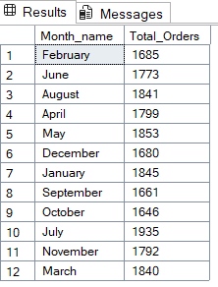

8. -- Percentage of total sales by pizza category
SELECT pizza_category,SUM(total_price) *100/(SELECT SUM(total_price) FROM [pizza_sales (1)])
FROM [pizza_sales (1)]
GROUP BY pizza_category;
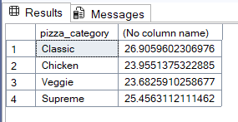

9. Percentage of sales by pizza size

SELECT pizza_size,SUM(total_price) *100/(SELECT SUM(total_price) FROM [pizza_sales (1)]) as pct
FROM [pizza_sales (1)]
GROUP BY pizza_size
ORDER BY pct;

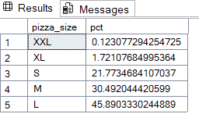

10.

SELECT TOP 5pizza_name,SUM(total_price) AS total_revenue FROM [pizza_sales (1)]
GROUP BY pizza_name
ORDER BY total_revenue DESC ;

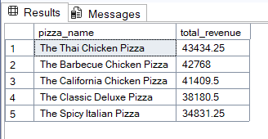

11. -- Bottom 5 pizzas by revenue
SELECT TOP 5pizza_name,SUM(total_price) AS total_revenue FROM [pizza_sales (1)]
GROUP BY pizza_name
ORDER BY total_revenue ;

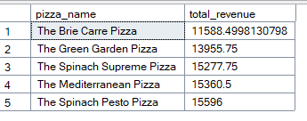

12. -- Top 5 pizzas by quantity
--SELECT TOP 5pizza_name,SUM(quantity) AS total_quantity FROM [pizza_sales (1)]
--GROUP BY pizza_name
--ORDER BY total_quantity DESC ;

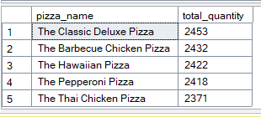

13. Botttom 5 pizzas by Quantity

SELECT TOP 5pizza_name,SUM(quantity) AS total_quantity FROM [pizza_sales (1)]
GROUP BY pizza_name
ORDER BY total_quantity ;

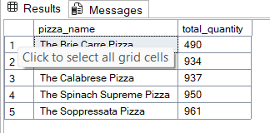

14.
-- Top 5 pizzas by Orders
SELECT TOP 5pizza_name,Count(DISTINCT order_id) AS total_orders FROM [pizza_sales (1)]
GROUP BY pizza_name
ORDER BY total_orders DESC ;

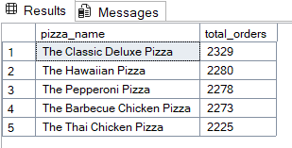

15. -- BOTTOM 5 pizzas by Orders
SELECT TOP 5pizza_name,Count(DISTINCT order_id) AS total_orders FROM [pizza_sales (1)]
GROUP BY pizza_name
ORDER BY total_orders ;

